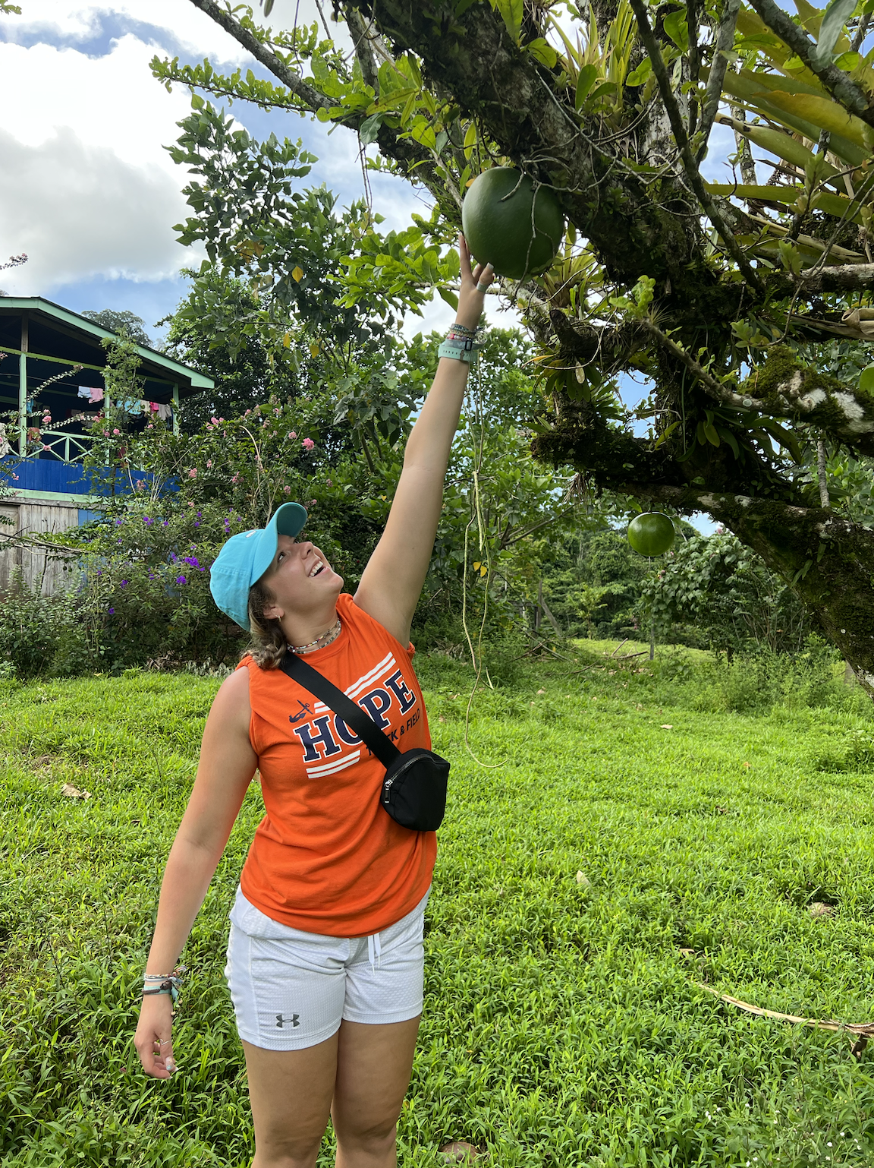

Kamryn Bice

Project Description: Kamryn Bice is leading research examining the behavior of Lake Tanganyikan cichlids using underwater footage. It is in this East African great lake that cichlids appear most ecologically differentiated. So, studying their behavior and how these interact in the wild may reveal clues as to how these closely related species coexist.

Personal Write-Up: Kam is a junior Biology major and Environmental Science minor, who loves to be outside. She enjoys spending time with her friends, thrifting, making embroidery, working out and throwing on the Track and Field team.

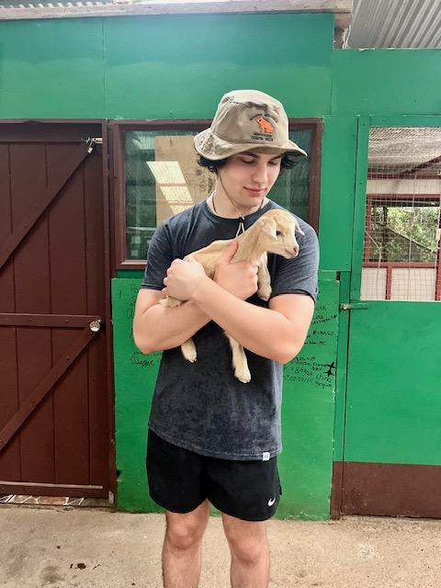

Project Description: Lucas Day and CC Shaffer kickstarted the lab’s research involving detecting invasive carp (silver carp and bighead carp, collectively referred to as bigheaded carps) in local aquatic ecosystems using environmental DNA. CC also collected water samples in Saint Joseph, a location in Lake Michigan where environmental DNA of bigheaded carps had already been detected before using this same technique (prior study linked below).

<https://www.michigan.gov/invasives/news/2023/09/28/no-silver-carp-in-new-river-samples>

Personal Write-Up: Lucas is currently in his junior year and is from Onsted, Michigan. He is planning on becoming a PA and currently works as a direct care worker for adults with special needs. Lucas enjoys working out, hanging out with my friends, and golfing. Lucas also explored Costa Rica as part of the Coffee-themed May term course at Hope College.

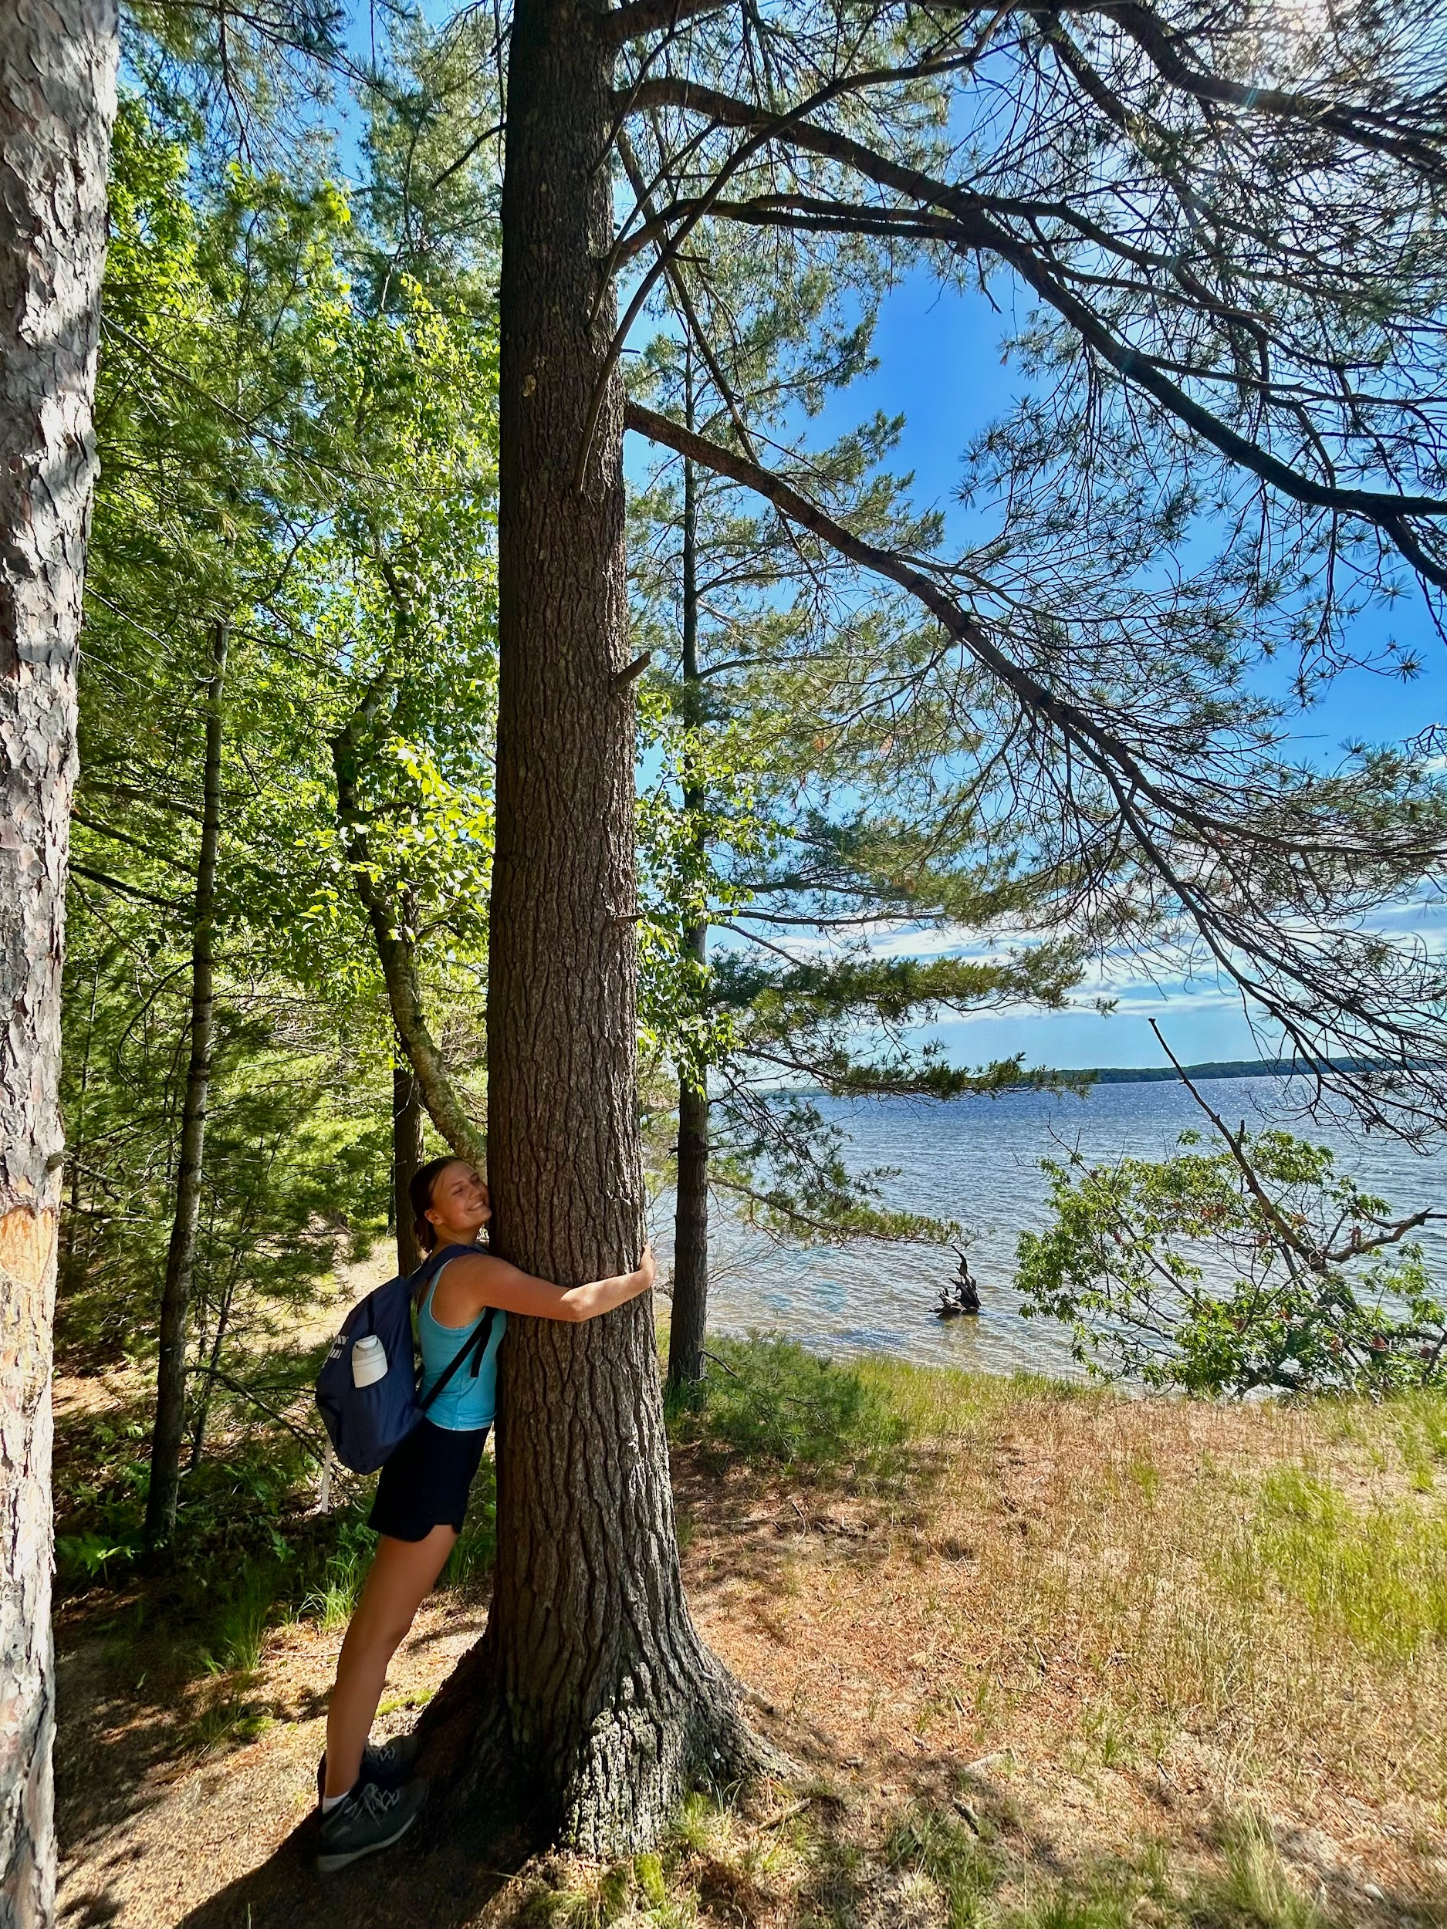

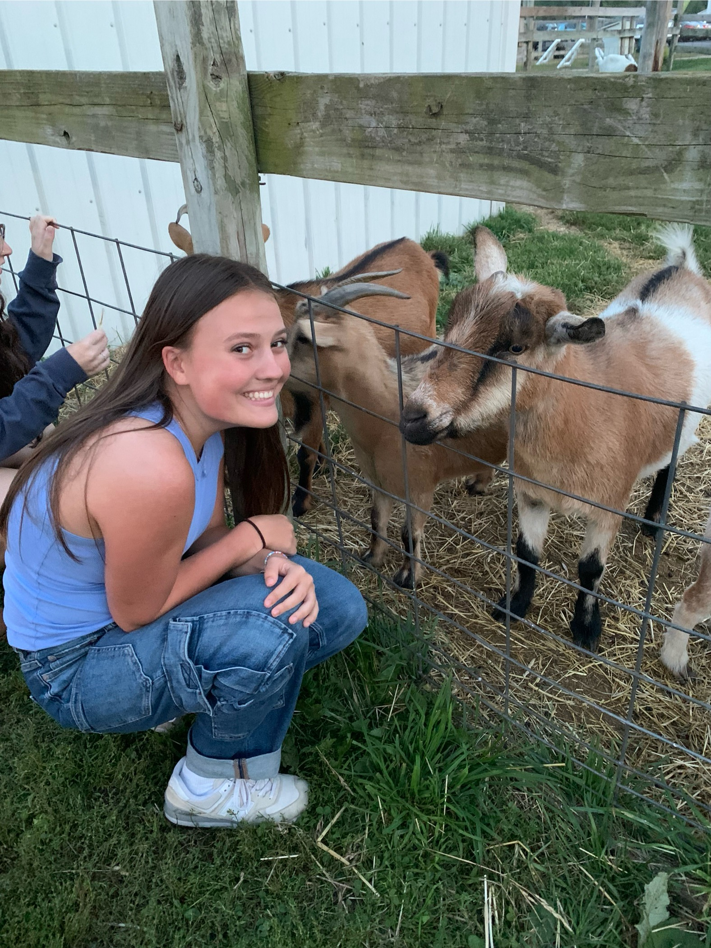

CC Shaffer

Project Description: CC Shaffer together with Lucas kickstarted the lab’s research involving detecting invasive carp(silver carp and bighead carp, collectively referred to as bigheaded carps) in local aquatic ecosystems using environmental DNA. CC also collected water samples in Saint Joseph, a location in Lake Michigan where environmental DNA of bigheaded carps has already been detected before using this same technique.

<https://www.michigan.gov/invasives/news/2023/09/28/no-silver-carp-in-new-river-samples>

Personal Write-Up:

CC is a sophomore majoring in Environmental science with a Biology concentration, and plans on pursuing a career in marine biology research. In her free time she enjoys hiking, going to the beach, spending time with friends and family, and walking her dog ‘Bingley.’

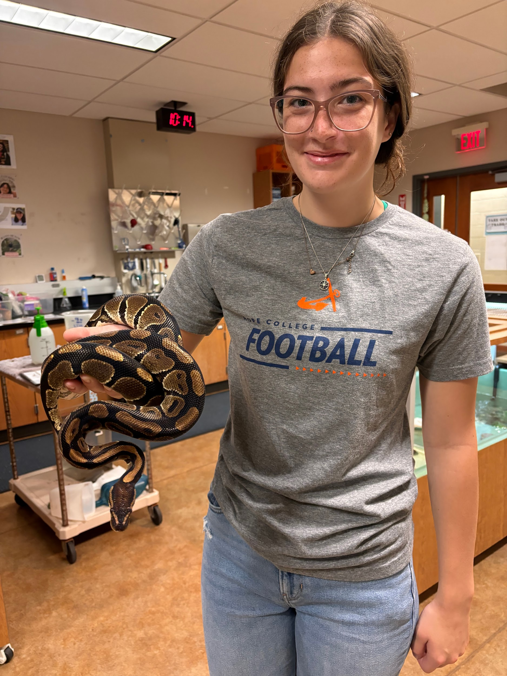

Natalie Terry

Project Description: Natalie is leading a research project determining how otoliths vary in invasive carp populations.

Personal Write-Up:

Natalie is a sophomore majoring in Biology on the pre-vet track with minors in Spanish and Political Science. In her free time, she enjoys reading, working out, making coffee, spending time with her family, and being outdoors.

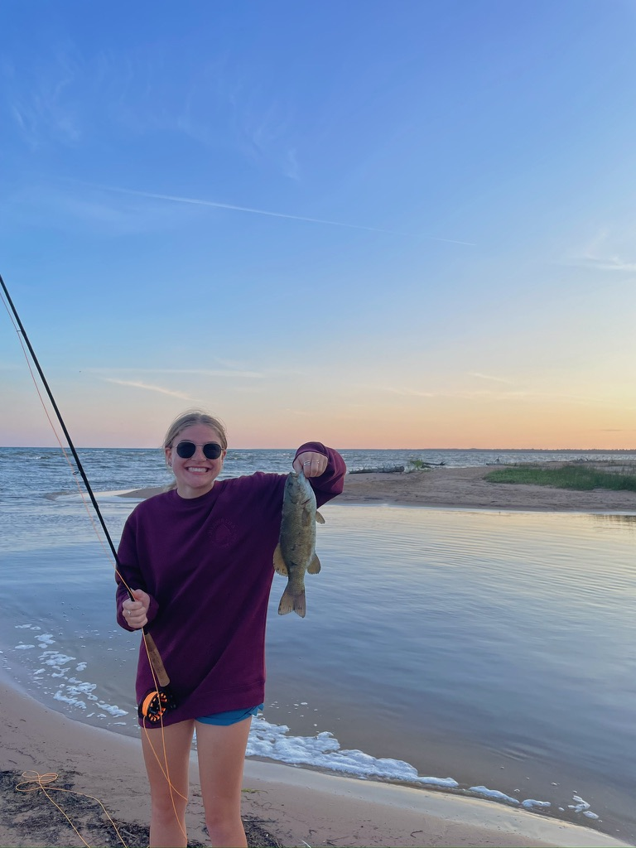

Project Description: Annie Waldron is leading a research project monitoring Lake Sturgeon using environmental DNA in local aquatic ecosystems.

Personal Write-Up: Annie really enjoys being outdoors, whether that's hiking, fishing, or just sitting in the sun. She loves all animals, especially her two dogs, Winston and Georgia. She loves to go on long walks, try new recipes, watch movies, and make crafts.

Dr. Golcher-Benavides

Past project names, special interests, etc.

Personal Write-Up: